

Tutorial - week3

Group: Xeon



*Intelligent routing for smart skips*

Members

Joel Benesha – s280615

Yinrui Kang- S299806

Chao Liang- S304935

YUZE LI - s306890

YUCHU HAN - S300408

March 22, 2018

# Scope

Skips are rubbish bins collected by the city council from constructions and commercial sites. These skips are sometimes full and need to be emptied. The objective of the project is to develop a smart skip sensor which sends signals to a Mobile application. The intention of the app is to detect whether a skip is full or empty. The result obtained from the sensor will determine whether the skip needs to be emptied or not. The application will notify the users in the process and Alert landfill operators about the skipload. The design will incorporate route mapping and if full the skip will be taken to different destination depending on it contains. The skip with concrete needs to be taken to the concrete crushers and the skips with mixed waste to the landfill. The application will provide the shortest route from source to the intended destination of the skip through implemented features such as Google map. The project will not focus on a physical component but will use dummy database to achieve the task. Furthermore, the project will not address any other feature or issue and will focus on developing an intelligent routing for smart skips.

**Project Exclusions: Statements about what the project will not accomplish or produce.**

## Constraints:

* Lack of human resources
* Limited resources
* Cost – check with the client
* Time
* Development knowledge

## Assumptions: Address uncertain information as you conceive, plan, and perform your project.

* + Free software, personal resource, workout.
  + Reduce features and keep main features, rearrangement of cost
  + Better time management, feasible
  + Project management
  + Scheduling and meeting deadlines
  + Communication with the client (weekly meeting)
  + Constant progress meeting

# Milestones- YUZE LI

# Project plan -YINRUI KANG

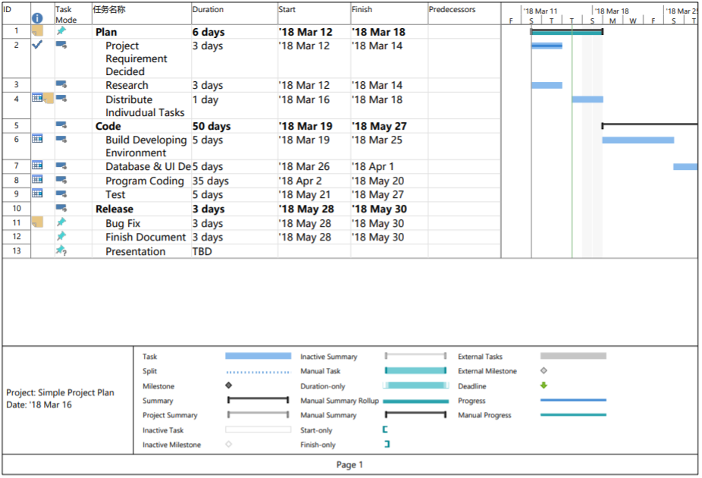

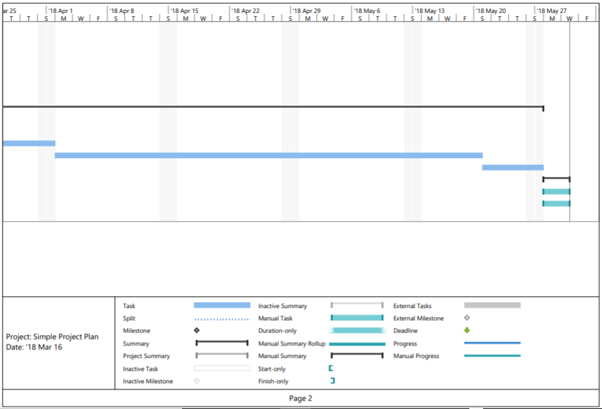

# User Story

As a truck driver, I would like a simple application to be able to notify me if the skip is full. The application should have route mapping for skips, finding the shortest path from the source to the destination. It should also alert the landfill operator about the skipload. The application would allow me to work effectively and efficiently.